**Title Page**

**Project Title:** Music Band Website Page  
**Submitted By:**

* Name: RINEETH S E , PRAJWAL S HANGARGI , PRAJWAL V L
* Roll Number: 2462834 , 2462125 , 2462181
* Email: [prajwal.s@btech.christuniversity.in](mailto:prajwal.s@btech.christuniversity.in) , rineeth.s@btech.christuniversity.in , [prajwal.vl@btech.christuniversity.in](mailto:prajwal.vl@btech.christuniversity.in)   
  **Course:** UI/UX Design Fundamentals  
  **Instructor Name:** Ms.Nagaveena  
  **Institution:** Christ University  
  **Date of Submission:** 13/08/2025

**Abstract**

This project involves designing and developing a fully responsive website page for a music band using HTML5 and CSS3. The page showcases the band’s identity, upcoming events, music albums, and contact information. The goal is to create an immersive and engaging experience that reflects the band’s style and energy. The design emphasizes bold visuals, clear navigation, and mobile-first responsiveness. The final output provides fans with easy access to band information, enhancing their connection with the artists.

**Objectives**

* Design a visually striking and brand-consistent website page for a music band.
* Ensure responsive performance across desktop, tablet, and mobile devices.
* Use HTML5 semantic elements to structure content effectively.
* Apply CSS3 for stylish typography, colors, and layouts.
* Highlight multimedia elements such as images and embedded music players.

**Scope of the Project**

* Front-end design only; no back-end integration.
* Includes sections for Home, About the Band, Albums, Events, and Contact.
* Mobile-first approach to ensure smooth viewing on all devices.
* Uses only HTML and CSS (no frameworks or JavaScript libraries).

**Tools & Technologies Used**

| **Tool/Technology** | **Purpose** |
| --- | --- |
| HTML5 | Structure and content markup |
| CSS3 | Styling and responsive design |
| VS Code | Code editing |
| Chrome DevTools | Testing and debugging |

**HTML Structure Overview**

* **Header:** Band logo and navigation menu.
* **Hero Section:** Full-width background image of the band with a tagline.
* **About Section:** Introduction to the band members and their story.
* **Albums Section:** Grid of album covers with brief descriptions.
* **Events Section:** List of upcoming concerts and performances.
* **Contact Section:** Social media links and a placeholder contact form.
* **Footer:** Copyright and quick navigation links.

**CSS Styling Strategy**

* External stylesheet (style.css) organized into sections.
* Flexbox and Grid for album layouts and event listings.
* Media queries for adapting typography and layout across screen sizes.
* CSS variables for theme colors matching the band’s brand.
* Hover effects for interactive elements such as album covers and buttons.

**Key Features**

| **Feature** | **Description** |
| --- | --- |
| Responsive Design | Optimized for all device sizes |
| Hero Banner | High-impact imagery to represent the band |
| Albums Showcase | Visual grid of album covers |
| Events List | Clear display of upcoming performances |
| Social Integration | Links to the band’s social media pages |

**Challenges Faced & Solutions**

| **Challenge** | **Solution** |
| --- | --- |
| Image scaling on smaller devices | Used object-fit: cover and responsive sizing |
| Maintaining text readability on background images | Applied semi-transparent overlays |
| Aligning albums in a grid format | Used CSS Grid with auto-fit and minmax properties |

**Outcome**

* Successfully delivered a stylish, brand-consistent, and fully responsive music band website page.
* Improved skills in multimedia presentation through HTML and CSS.
* Learned effective layout strategies for content-heavy and image-rich designs.

**Future Enhancements**

* Integrate JavaScript for audio playback and interactive features.
* Add a ticket booking section for events.
* Include video backgrounds in the hero section.
* Create a blog section for news and updates.

**Sample Code**

**<!DOCTYPE html>**

**<html lang="en">**

**<head>**

**<meta charset="UTF-8">**

**<meta name="viewport" content="width=device-width, initial-scale=1.0">**

**<title>The Rockers - Official Band Website</title>**

**<link rel="stylesheet" href="style1.css">**

**<link href="https://fonts.googleapis.com/css2?family=Oswald:wght@400;700&display=swap" rel="stylesheet">**

**<script src="https://kit.fontawesome.com/a076d05399.js" crossorigin="anonymous"></script>**

**</head>**

**<body>**

**<!-- Sticky Header -->**

**<header class="header">**

**<div class="logo">THE ROCKERS</div>**

**<nav>**

**<a href="#hero">Home</a>**

**<a href="#about">About</a>**

**<a href="#tour">Tour</a>**

**<a href="#gallery">Gallery</a>**

**<a href="#contact">Contact</a>**

**</nav>**

**</header>**

**<!-- About Section -->**

**<section id="about" class="about">**

**<h2>About the Band</h2>**

**<div class="about-content">**

**<img src="images/band.jpg" alt="Band Photo">**

**<p> The Rockers are a powerhouse of pure rock energy, blending classic riffs with a modern edge. Formed in 2010, the band has played in over 20 countries and continues to thrill audiences with electrifying performances.**

**</p>**

**</div>**

**Screenshots of Final Output**

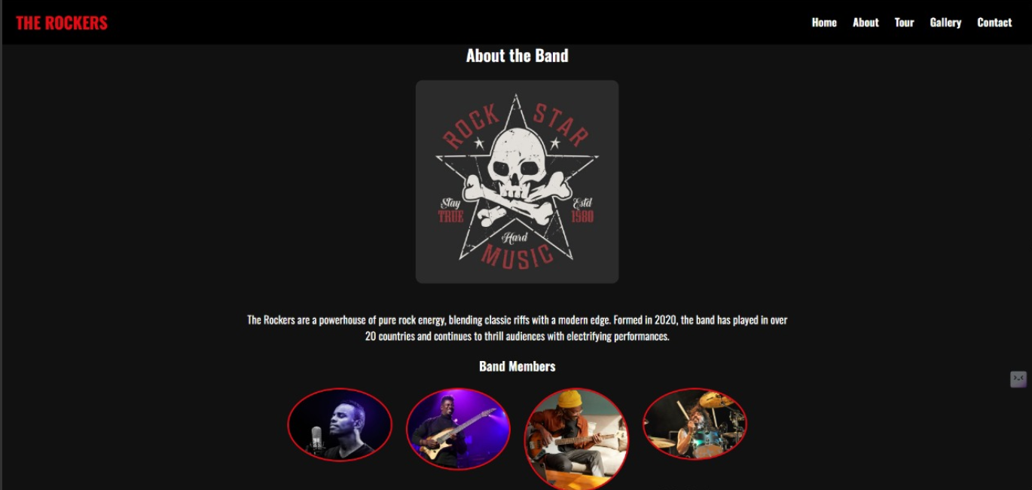

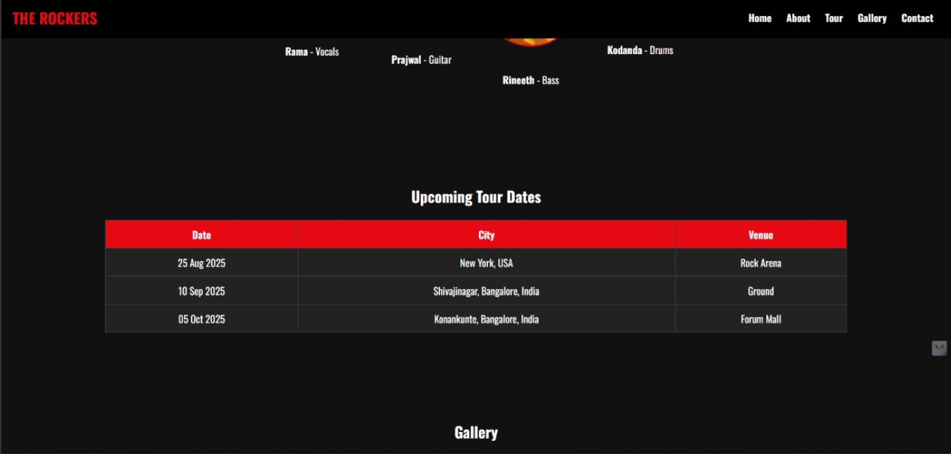

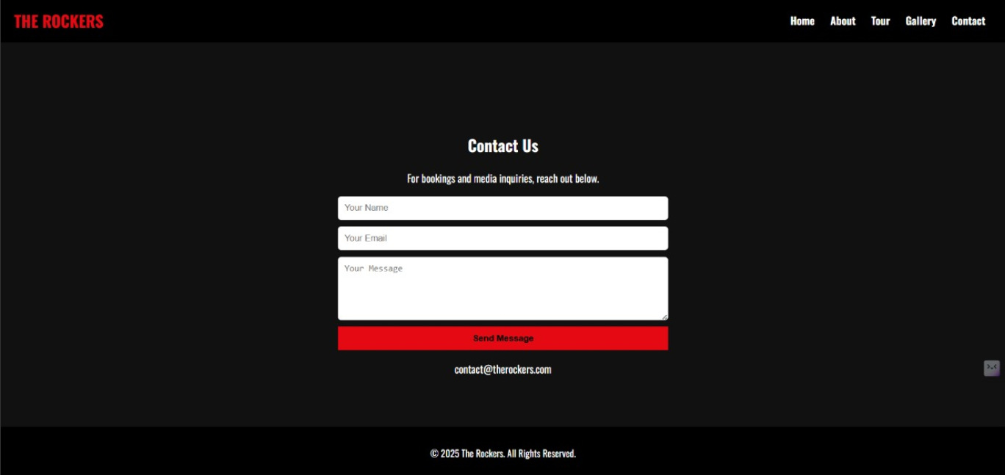

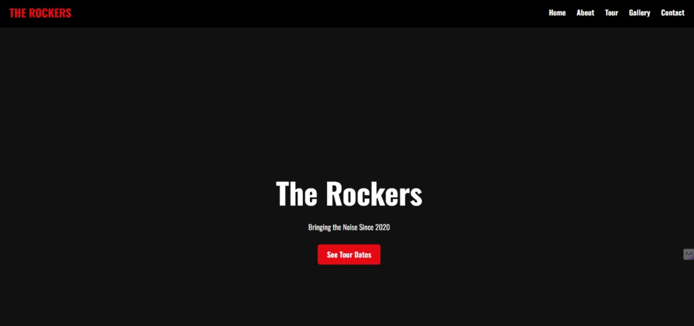

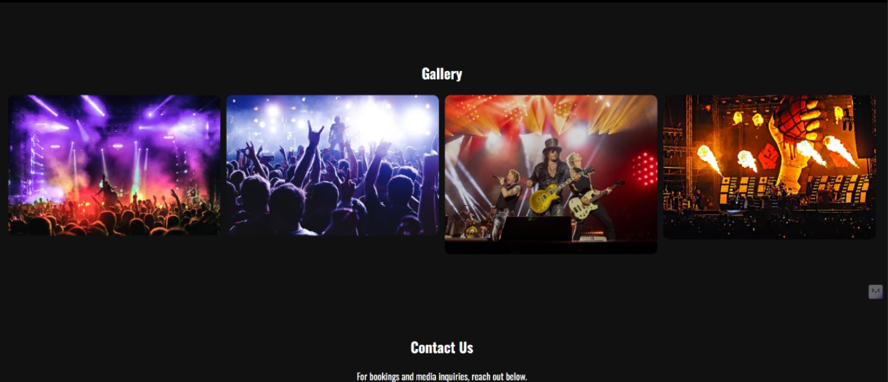

**Conclusion**

This music band website page project enhanced my ability to design brand-specific, responsive, and media-rich web pages. I gained valuable experience in arranging multimedia content in a visually appealing manner, ensuring accessibility and performance across different devices.

**References**

* L&T LMS: <https://learn.lntedutech.com/Landing/MyCourse>